F-100D Super Sabre
113. Filo “Pirates”, Turkish Air Force
Lt. Azmi GÜROL
10 November 1971, Malatya - Erhaç AB

The Aircraft:
In the early 70s, First Lieutenant Azmi GÜROL was an F-100D pilot in the Turkish Air Force 7th Main Jet Base, 113. Filo “Pirates”(In 1972 was changed to 171. filo.) In Malatya Erhaç.

On November 10, 1971 First Lieutenant GÜROL took-off as formation leader for shooting practice. He flew F-100D 56-3390. The first shot hit the targets.
After the second shot the plane malfunctioned while conducting a standard reverse maneuver.
First Lieutenant GÜROL heard heavy scrapings and noise and started to do emergency landing procedures. On final approach while the landing gear was opening, a second explosion was heard. His aircraft was out of control. First Lieutenant GÜROL ejected and landed safely but 56-3390 crashed and burned. In 1988, Azmi GÜROL retired with the rank of lieutenant colonel and then he flew as captain pilot on Turkish Airlines. In 2006, Azmi Gürol passed away in age 61.

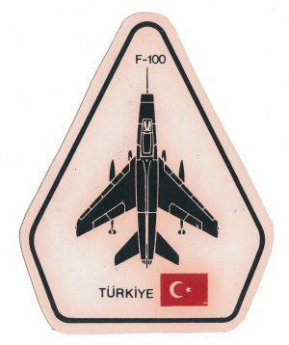 Turkish F-100 Patch

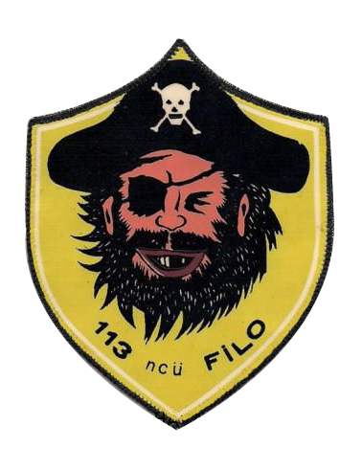
Old 113. Filo patch

